7.1.29 Editors - 3D View - Header - Text - Edit mode - Font menu
Edit Mode - Fonts Menu 2
Special Characters 2
Select Text 2
Move Cursor 2
Toggle Bold 2
Toggle Italic 3
Toggle Underline 3
Toggle Small Caps 3
Set Uppercase 3
Set Lowercase 3
Last Operator Set Case 3
Kerning 3
Decrease Kerning 3
Increase Kerning 3
Reset Kerning 3
Last Operator Change Spacing 3
Delta 3
Delete 3

Edit Mode - Fonts Menu

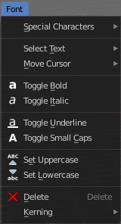

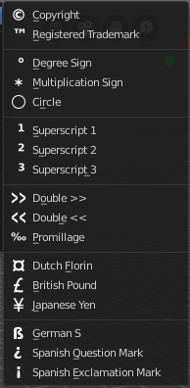
Special Characters
Special characters is a sub menu that contains some special text characters, like copyright, which you can insert into the text.

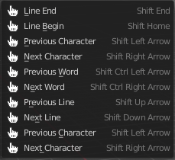
Select Text
Select text is a sub menu that contains selection functionality, starting from the current position of the Textcursor. The buttons should be self explaining. And usually you use the hotkeys for this functionality.

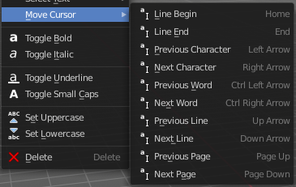
Move Cursor
Set the cursor at specific positions in the text.

Toggle Bold
Bold sets the selected letters to be displayed as bold letters.

Toggle Italic
Italic sets the selected letters to be displayed as italic letters.

Toggle Underline
Underline sets the selected letters to be displayed as underlined letters.

Toggle Small Caps
Toggle small caps sets the selected letters to be displayed as if they were upper case letters, but with lower case size.

Set Uppercase
Sets the selected text to be uppercase letters.

Set Lowercase
Sets the selected text to be uppercase letters.

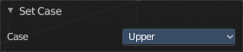
Last Operator Set Case
Set Case has one Last Operator for all items.

Kerning
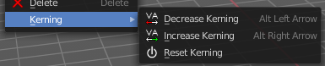
Kerning is the distance between letters. Here you can increase, decrease and reset the kerning.

Decrease Kerning
Decreases the distance between the letters.

Increase Kerning
Increases the distance between the letters.

Reset Kerning
Resets the distance between the letters to the default values from the font.

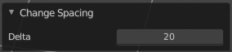
Last Operator Change Spacing

Delta
Here you can adjust the spacing. The range goes from -20 to 20.

Delete
Deletes the selected text.

